**Using Cloud Infrastructure as computing power for Robotic and Autonomous Systems**

**Ninad Sanjay Dhuri**

San Jose State University

1ninadsanjay.dhuri@sjsu.edu

**Abstract**

**Robotics as a field has had a huge effect this decade with the development of machine learning and AI. It is amazing that modern robots can carry out jobs in a real-time setting. Robots employ built-in automation systems that are capable of programming, memory management, and computing. However, utilizing autonomous robots for human-scale task manipulation necessitates giving them knowledge and reasoning capabilities [1]. The Cloud infrastructure and its vast array of services that can be accessed over the Internet may be extremely advantageous for automation and robot systems. We take into account automation systems and robots that depend on network data to function, i.e., those that lack a single independent unit that houses all sensing, computing, and memory. The following are the potential four benefits of the cloud: I) Robots sharing trajectories, control strategies, and results is known as collective robot learning; cloud computing for statistical analysis, education, and motion planning; and II) big data: access to libraries of photos, maps, trajectories, and categorical data. III)Human computation: By leveraging crowdsourcing, experts in data analysis, picture and video analysis, categorization, learning, and error recovery can be accessed. Models, benchmarks, simulation tools, journals, datasets, and open design are all accessible and system contests, and open-source software are other ways that the Cloud could improve automation and robot systems.**

**Keywords *-* Big data, cloud automation, cloud, design, robots, computing, cloud-robotics, crowdsourcing, open source.**

**1. Introduction**

Over the past ten years, autonomous systems have developed and found use in a variety of industries as a result of advances in science and technology. Robotics and autonomous systems have had a social and economic impact on people's lives. For instance, it is difficult to envisage an industrial facility or industry today that does not have an autonomous system at the core of its performance. These industrial robots perform boring, repetitive chores that reduce a person's productivity in addition to making industrial workers' jobs easier. They take the least amount of physical effort from a worker's perspective because they are not prone to errors and are designed to carry out demanding jobs, allowing them to engage in painstaking labor and concentrate on the aesthetics of the product.

A user can use the services offered by cloud providers over the internet thanks to cloud computing. Without the need to set up those systems locally, they provide sophisticated computer systems to carry out a variety of functions. It is a commonly utilized technology that enables the person working on it to use the resources provided by the provider to perform the activities they ought to. Based on their availability across several zones, these resources are pooled and distributed among numerous consumers. The rapid scaling up and scaling down of resources based on load without human supervision, as well as data-intensive tasks like data storing, retrieval, and transformation to show the data, are all made easier with cloud computing. Instances of such service are Google Collaboratory, that gives a cloud-based Jupyter environment that uses Google Cloud Services and the computing power of the Google cloud engines to conduct computation, which enables users to store files on the disk. Three categories can be used to group clouds: Public clouds are those that are open to all users; private clouds are those that are only open to members of specific organizations or authorities; Hybrid: a combination of on-premises and cloud deployment.

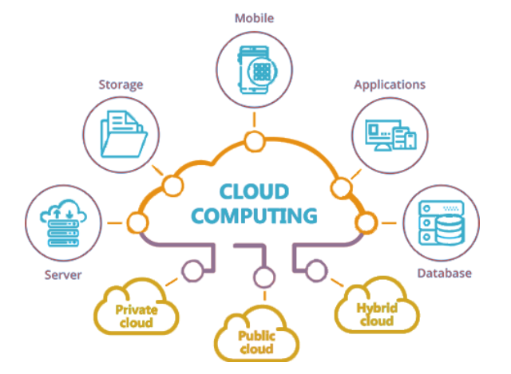

Fig 1. Cloud Computing

Interest in applying related ideas to robotics has increased as "Cloud Computing" has become more and more widespread. For example, cloud computing makes it easier to perform complicated calculation, information retrieval, data storage, and data analytics. By increasing memory and power management, it also aids in obtaining higher performance. Networked teleoperation and groups of robotic systems, including unmanned aircraft or industrial robotic systems that can construct, repackage, and polish items, are systems that are currently in use or may be developed. When responding to low-latency inquiries or when network access is unreliable or unavailable due to a variety of issues, including system availability, network latency, and service quality, Cloud Device and Autonomous platforms frequently need local processing. There isn't a system that perfectly satisfies the criteria in this definition. The standardization of devices shows a direct association with the move away from industrial manipulators and toward more adaptable, human-centered gadgets. Before humans were present, organizations like the International Standardization Organization (ISO) dealt with industrial manipulators, sometimes known as industrial robots. Such a governing authority is no longer necessary for interactions between humans and robots. Additionally, the concept of robots has evolved over time to include service robots that handle activities like handling equipment, stacking, and delivering to lessen the repetitious work of industrial workers. In robotics and automation services, this study tries to outline the advantages of cloud computing over onboard computing.

**2. Literature/State-of-the-Art Review:**

General Motors acknowledged the use of networked technologies to connect devices within automation systems more than 30 years ago. In the 1980s, MAP was created. They were followed by several other exclusive protocols until the World Wide Web's introduction of the HTTP over IP protocol in the early 1990s. Researchers created a user interface in 1989 that enables users to control a robot remotely using any Internet browser, and in 1994 they started to connect industrial robots to the Web. Researchers created several web interfaces for robots and other devices in the late 1990s.

The Technical Committee on Networked Robots of the IEEE Robotics and Automation Society was created in May 2001, and it has hosted several workshops on remote robotics. The benefits of remote robotics were discussed by Inaba *et al*. in 1997. Researchers at RoboEarch created software/hardware platform designs for service robotics in conjunction with a sizeable EU grant.

One of the many fields that have opened as a result of the cloud robotics and automation revolution is the "Internet of Things," which makes it possible to use a range of inexpensive processors in robots hooked up to the internet, enabling them to talk with each other and share information.

According to Germany, the industrial sector is experiencing the fourth industrial revolution as a result of these developments and new technology. The concept of "Industry 4.0" will be able to automate redundant and boring activities by utilizing mechanization and the computational capacity of parallel processors in a cloud setting. One such application is the software framework called DAvinCi, which was developed utilizing the Hadoop cluster and ROS (Robotic Operating system). The authors' approach produced superior results when they used Hadoop clusters. Additionally, a robot's map of the workspace was shared with newly arrived robots so they could begin working right away without having to go through the hassle of having to re-learn the pathways and workspace. DAvinCi offers service robots for extensive industrial areas by utilizing the benefits of cloud computing, such as parallelism.

**3. Problem that needs to be solved**

Systems for robotics and automation are in high demand and have been widely used to simplify tasks for users. However, it is challenging to carry out on-demand job adjustments since onboard computation, memory, and programming are present at the very heart of the robots. Because of this, maintaining robots becomes challenging and updating their functionality is expensive. The issue with onboard computation is that there aren't many resources available for real-time data analysis, which can result in poor decisions. Additionally, it is necessary to support learning in an autonomous system, but this is complicated by the single system architecture's restriction on access to fast computation. One of the areas where onboard robotic systems fall short is the ability to grasp and analyze a novel situation. This is because the data is not readily available. A single system architecture is also redundant and results in high resource costs for a multi-machine system. Like this, robots with onboard compute are unable to process massive data, such as photographs and trajectory data, due to a lack of processing capability. Such high-end tasks benefit from parallel processing and large amounts of computing power. In order to enable unhindered operations, including real-time task manipulations based on environmental analysis, it is imperative that cloud computing be incorporated into robot systems for processing and computation. This enables computing using shared resources, improved data management, and accessibility to numerous resources via the internet.

**4. Project Justification**

Robotic and automation systems are in high demand, and they have been widely deployed to make users' jobs easier. To carry out on-demand task adjustments, however, is difficult because the robots' very cores contain onboard computation, memory, and programming. Because of this, maintaining robots becomes challenging and updating their functionality is expensive. The issue with onboard computation is that there aren't enough resources available for real-time data analysis, which can result in poor decisions. Additionally, it is necessary to support learning in an autonomous system, but this is complicated by the single system architecture's restriction on access to fast computation.

The solution of the hour is a cloud-based strategy like Robotics and Automation as a Service (RAaaS). Using the computational power they offer; cloud infrastructure enables autonomous systems to carry out massive data operations. Additionally, they offer a vast resource base that can significantly enhance a robot system's processing. They also give autonomous systems a better learning environment by combining machine learning's simplicity of computing with it. This paper's goal is to examine and explore cloud-based strategies that can enhance robotic and autonomous systems. One of the areas where onboard robotic systems fall short is the ability to grasp and analyze a novel situation. This is because the data is not readily available. A single system architecture is also redundant and results in high resource costs for a multi-machine system. Like this, robots with onboard compute are unable to process massive data, such as photographs and trajectory data, due to a lack of processing capability. Such high-end tasks benefit from parallel processing and large amounts of computing power. In order to enable unhindered operations, including real-time task manipulations based on environmental analysis, it is imperative that cloud computing be incorporated into robot systems for processing and computation. This enables computing using shared resources, improved data management, and accessibility to numerous resources via the internet.

**5. Proposed Solution**

Right now, cloud-based strategies like Robotics and Automation as a Service (RAaaS) are the way to go. Large-scale data processing can be carried out by autonomous systems thanks to the computing capacity offered by cloud infrastructure. They also offer a vast resource base that can greatly enhance a robot system's processing. Additionally, they enable improved learning environments for these systems by fusing machine learning with the simplicity of computing provided by autonomous systems. In order to improve autonomic and robotic systems and boost their performance, this study will examine and explore several cloud-based strategies.

**6. Goals of the project**

Massively parallel computing is available on demand thanks to commercial systems like Google Compute Engine and Amazon Elastic Compute Cloud. Tens of thousands of processing resources are managed by these servers for quick tasks like web applications. Recently, they have been used more and more in autonomous systems and machine learning applications to carry out high computing tasks. Processing of complicated information, such as graph- and document-based datasets, is made possible via cloud computing. Additionally, they permit the use of multiple cloud-based platforms, machine learning frameworks, and complicated model implementation.

Numerous applications of robotics and automation that require a lot of processing can be accelerated by cloud computing. Robots used for navigation, object detection using image processing, and most frequently collaborative robots are included in this. object recognition by next-view planning. There has also been evidence of cloud-based formation control of ground robots. As well as computing sensor and command responses, cloud computing may also be utilized to compute the cross-product of several objects and environmental disturbances. In addition, as robots often create graphs, these graphs grow larger and more complicated as they operate. The generated graphs can be used to forecast better behavior for the upcoming iteration of autonomous systems. To get the necessary data and make data retrieval easier, one needs to apply a graph reduction technique to these graphs. With the use of cloud computing, these intricate algorithms can process huge amounts of graph data more quickly on a parallel grid of computers.

**7. Technical Aspects**

Service robot sales have increased significantly, as have efforts to grasp their consequences. Artificial intelligence and service robots hold the promise of boosting productivity and lowering costs. However, there is a dearth of marketing studies on this issue. The goal of the current paper is to complement studies on how human-like robots are by looking into the selection criteria the said mangers should make for just the robotic devices they engage in their service setting. Different categories categories—robot design, client characteristics, and service encounter characteristics—are divided into essential elements that must be examined collectively to determine how best to adapt them to various service components. Definitions, ideas that overlap, prior knowledge of each variable, and unresolved research gaps are all clarified.

Robots are technical beings with some genuine or simulated human traits, as this definitional effort suggests. A service robot proposes a middle ground in service environments that were traditionally occupied by either employees or machines; they have technological elements but can also interact with people. Customers can connect with them socially, unlike when using self-service technologies, making them feel as though customers are communicating with a different person that is offering services. The features of the clients also affect these perceptions. In contrast to technologies that need the work of customers or employees, service robots also operate independently under AI's control.

Given these unique attributes, we must integrate the visual elements of the robot—such as whether it can recognize social signals. The judgments taken in each of the three factors, or dimensions, are combined to determine the adoption, customer contentment, and provider loyalty of service robots, as demonstrated in Figure 2. Finding the perfect mixture is challenging. For example, a younger customer seeking information on a financial service (customer features) could prefer casual and chill conversations with a chatbot (robot design).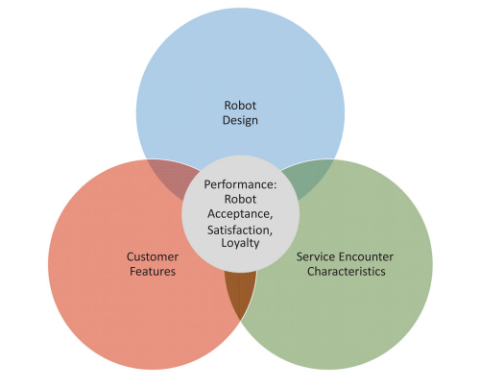

Fig 2. 3 divided architectures for service robots.

**7.1 Robot Design**

Beginning with the challenges presented by robot designs, which are meant to improve relationships between customers and service providers. Most of the earlier research on robotics was on how human emotions and views of robots are impacted by aesthetics and physical appearance. However, there are a lot more options available when it comes to robot design. As a result, we consider these components to construct six essential features for service robot design, as shown in Figure 3.

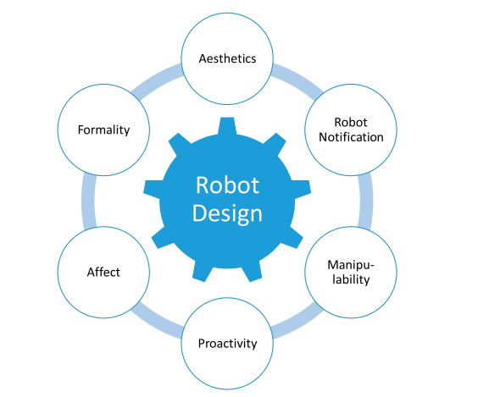

Fig 3. Elements of design of service robots.

**7.1.1 Aesthetics**

As was said earlier, earlier robotics research has mainly concentrated on aesthetics and physical looks, frequently assuming a favorable association between a robot's resemblance to humans and consumers' acceptance. However, it is unclear what the ideal level of human likeness is. Greater level of human appearance generally seems to improve emotional attachment, encourage favorable judgments and attitudes, as well as a rise in robot preference. This beneficial effect most likely results from the human-like congruency of a technology object's look, which makes it easier for customers to access a human schema.

**7.1.2 Robot Notification**

Clients should be aware that they are engaging with a robot is a crucial choice in the design of a service robot since the robot notification informs them of it. Although this choice is particularly crucial for robots (such as chatbots) whose components are hidden from clients, robots are evolving to look more like people and may eventually blend in. Customers' expectations of the interaction are based on how aware they are that they will be interacting with a robot. The Turing test is a well-known challenge that explores the possibility of robots becoming so proficient at interacting with humans that humans cannot certify that they are doing so. This Turing test has been passed by several robotic conversational agents; Eugene Goostman, a chatbot, was the first to succeed in 2014.Humans are less conscious of a machine in a service environment if they cannot definitively tell that they are speaking to one. Customer awareness can occur on several levels (social, task, and work awareness), each of which might lead to a different conclusion, idea, or behavior. Service providers must weigh all their options, including notifying the client upfront, after the fact, or not at all, to avoid unfavorable outcomes. Many companies are competing to create an unrecognizable robot with a nearly flawless human appearance.

**7.1.3 Manipulability**

Customers may alter their service experience based on their individual preferences or the nature of the communication. Customers have different perspectives on control when it comes to service robots like vehicles, heaters, and lawnmowers. Increased consumer value co-creation is implied by more manipulable robots. The concept of manipulability is closely related to the idea of psychological ownership, which emerges from a sense of control or ownership because an extended self is present. The degree of manipulability may also have a significant impact on accountability in the event of a poor result. Companies can plan how customers physically engage with robots.

**7.1.4 Proactivity**

Proactive service behavior occurs in human-robot interactions when the robot starts the conversation or offers proactive assistance. Instead of only reacting to inquiries, a proactive frontline service robot might start the conversation, provide support, or look for chances to assist clients. Proactivity and a more reactive approach can both result in better service outcomes for front-line staff who are dealing with people. Although customer responses to proactive robots may resemble those to proactive human employees, there are also likely to be some differences, especially when we take into account the complementing influences of flow in human-robot interaction. Robots and human frontline personnel likely react to client stimuli differently in terms of the amount of information they provide and the speed of their responses. The anticipation of a reaction may result in either favorable or unfavorable customer perceptions and satisfaction levels.

**7.1.5 Affect**

One of the most difficult design problems facing designers today is the inclusion of emotions in robotic agents, and success seems to be decades away. Particularly, empathy is crucial to interactions between employees and customers in customer service, but it also represents a very high level of affective performance for service robots. Nevertheless, some of the four categories of emotional intelligence are already met by AI technology. Robots can recognize human emotions thanks to AI, and they can even act as though they do. Furthermore, humans are adept at deciphering emotive signs from robot movements and behaviors. Service robots with physical appearance use accurate facial expressions and body language to communicate their emotions.

**7.1.6 Formality**

The formality of the customer-robot relationship is also influenced by design. In formal interactions, an actor abides by strict rules and normative recommendations; nevertheless, in informal interactions, prerogative and individuality prevail. Different communication styles, ranging from the exceedingly formal to the extremely informal, can be integrated into robots. When a robot converses with a kitchen worker in a research study, people react in awe, which leads to uncertainty and unfavorable affective reactions. Robots like Clever Bot and others that are funny may respond to messages with memes, jokes, or wit.

**7.2 Customer Features**

Service robots are an example of a disruptive invention that, depending on the customer's capacity to handle the innovation or disruption, is viewed and embraced differently by various customers. When faced with a new, disruptive technology, many people feel amazement or terror. As robots become more socially active in-service situations and offer both technological advancements and a certain amount of humanity, this connection becomes more difficult. Important customer attributes to consider when using service robots are shown in Figure 4.

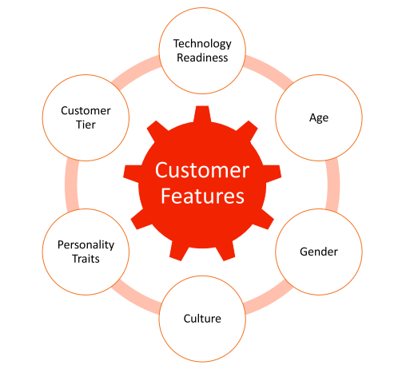

Fig 4. Key customer features for service robots

**7.3 Service Encounter Characteristics**

According to the type of service and how well the service robot adjusts to the circumstances of the service encounter, frontline chemistry when providing "moments of truth" can vary significantly, as shown in Figure 5. Robots that aren't meant to interact with people, for instance, might not necessarily need to seem human, but if they're going to be present in any setting where people might be working or visiting, they'll need to possess the necessary amount of core qualities, like size, speed, or security. To be integrated into a social environment, service robots' qualities must adhere to normative criteria even if they lack distinctive human attributes. For instance, even if simple robots do not communicate, their high height and speed make people feel more threatened and anxious. These factors become even more important in-service interactions since people are used to communicating in accordance with fundamental societal standards.

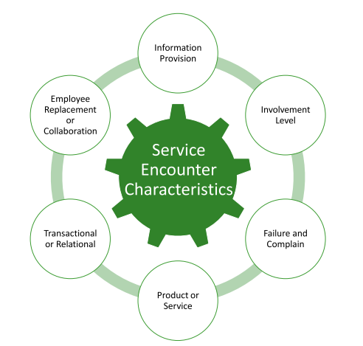

Fig 5. Important aspects of service robot encounter features

**8. Conclusion**

For businesses in logistics, manufacturing, fulfillment, and other sectors where automation is frequently needed to not just stay competitive but also to address manpower shortages, the high cost is frequently a significant barrier to entrance. However, some robotics businesses are going a different route when it comes to selling their robots entirely. Instead, they are implementing a robotics-as-a-service business model so that their clients may lease or rent robots without having to pay a hefty sum up front.

Robots as a Service, sometimes known as RaaS, refers to robotics as a service. RaaS involves renting robotic equipment rather than buying it outright. This is comparable to the way software as a service (SaaS) enables businesses to lease software. However, via a cloud-based subscription, you are contracting to use a service's robotic devices rather than its software.

Businesses can gather, process, and store data gathered by robotic devices with the aid of a cloud based RaaS. Sharing this information with nearby robots or human workers enables the business to make changes to its operations with the least amount of downtime. This increases the overall efficiency of the system and makes it more reliable.

RaaS is gaining popularity swiftly, and it is anticipated that this trend will continue in the next few years. According to some estimates, the global market for robots as a service would increase at a CAGR of 16.5% between 2022 and 2028. For the purpose of comparison, the historical CAGRs for a web-based software are 10.55 percent and 8.90 percent, respectively, for the market for telecommunications hardware.

RaaS lowers a company's upfront costs, which is one of its key advantages. Given their sophistication, robotics can be an expensive investment. Leasing them enables access to the innovations that robots offer without having to spend the money necessary to buy them outright. Additionally, because the robots are rented, the business is spared the expense of robot upkeep and updates. Smaller companies and companies with limited financial means can profit from robotics through the use of RaaS without having to take out loans or find other sources of funding for this equipment. This makes it easier for these organizations to compete with some of their bigger rivals or businesses that might have the resources to buy this equipment outright. This also makes the RaasS a more economic option as compared to buying the whole robotic system.

One notable negative of RaaS is the level of hardware customization necessary to make the robots useful for businesses with demands. Working together as humans and robots can be challenging. Negative safety precautions and a disconnect in communication between human and robotic services are present. A lot of energy would be required to run such a wide range of processes, hence efficient electric power sources must be created. Cybersecurity is another issue.

The Internet of Things (IoT) is indeed a system for device-to-device data exchange, yet it is vulnerable to online threats. Another issue is how it performs. There will always be doubt about how well the robot’s function because RaaS is a new and unproven business model until they can be trusted to fulfill their promises.

**9. References**

[1] M. Beetz, M. Tenorth, and J. Winkler, “Open-EASE,” *IEEE International Conference on Robotics and Automation (ICRA),* 2015.

[2] F. Chen *et al*., “A smart cloud robotic system based on cloud computing services,” *7th International Conference on Cloud Computing and Big Data (CCBD),* 2016.

[3] K. Kamei, S. Nishio, N. Hagita, and M. Sato, “Cloud networked robotics,” *IEEE Netw., vol. 26, no. 3, pp. 28–34,* 2012.

[4] M. Tenorth, K. Kamei, S. Satake, T. Miyashita, and N. Hagita, “Building knowledge-enabled cloud robotics applications using the ubiquitous network robot platform,” *IEEE/RSJ International Conference on Intelligent Robots and Systems*, 2013.

[5] S. Jordan, T. Haidegger, L. Kovacs, I. Felde, and I. Rudas, “The rising prospects of cloud robotic applications,” *Proc. Int. Conf. Comput. Cybern. (ICCC), pp. 327–332,*2013.

[6] E. Guizzo, “Robots with their heads in the clouds*,*” *IEEE Spectr., vol. 48, no. 3, pp. 16–18*, 2011.

[7] L. Turnbull and B. Samanta, “Cloud robotics: Formation control of a multi robot system utilizing cloud infrastructure,*“ Proceedings of IEEE Southeastcon*, 2013.

[8] N. H. Sanfeliu and A. Saffiotti, Eds., “Network Robot Systems,” *Robotics and Autonomous Systems A,*2008.

[9] R. Arumugam *et al*., “DAvinCi: A cloud computing framework for service robots*,” IEEE International Conference on Robotics and Automation,* 2010.

[10] G. Hu, W. Tay, and Y. Wen, “Cloud robotics: architecture, challenges and applications,” *IEEE Netw., vol. 26, no. 3, pp. 21–28,* 2012.